

**T.E. PROJECT REPORT**

**On**

**Hand Guesture recognition using motion sensors**

Submitted by

**YOGESH DABIR(T150023026)**

**MANGESH GANDHEWAR(T150023041)**

**DIVAKAR PAWAR(T150023034)**

Project Guide

**Dr. V.V. GOHOKAR**

**(Internal Guide)**

**Year: 2017-18**

Maharashtra Institute of Technology, Pune - 38

Department of Electronics and Telecommunication



MAEER'S

**MAHARASHTRA INSTITUTE OF TECHNOLOGY, PUNE**

**CERTIFICATE**

This is to certify that the project entitled

**hand Guesture recognition using motion sensors**

has been carried out successfully by

**YOGESH DABIR(T150023026)**

**MANGESH GANDHEWAR(T150023041)**

**DIVAKAR PAWAR(T150023034)**

during the Academic Year **2017-2018** in partial fulfillment of their course of study for

Bachelor’s Degree in

**Electronics and Telecommunication**

as per the syllabus prescribed by the

**SavitribaiPhule Pune University.**

**Dr. V.V. Gohokar Prof. Dr. B.S.Chaudhari**

Internal Guide Head of Department

(Electronics &Telecommunication) MIT, Pune.

**Acknowledgement**

This work is the result of inspiration support, guidances and co-operation that is extended to us at their best by our teachers, especially our guides.

We are grateful to Dr.**V.V.Gohokar and Prof. S.N. Jadhav**, for their valuable guidance throughout the preparation of this project report and most of all believing in us. Sometimes a little belief is all you need to go the extra mile.

We also thank our seniors whose support has played an instrumental role in completion of our project.

**Abstract**

Gesture Controlled Robot is a robot which can be controlled by simple gestures. The user just needs to wear a gesture device which includes a sensor. The sensor will record the movement of hand in a specific direction which will result in the movement of the robot in the respective direction. The robot and the Gesture device are connected wirelessly via radio waves. The wireless communication enables the user to interact with the robot in a more friendly way.

**Index**

|  |  |
| --- | --- |
| **Name** | **Page No.** |
| Chapter 1**:** Introduction  1.1: processing  1.2**:**Scope of the project | 1  3  4 |
| Chapter 2 **:**Literature survey  2.1:literature review  2.2: Present scenario and challenges | 5  5  6 |
| Chapter 3:System theory  3.1:Gesture recognition  3.2:Dynamic time warping | 7  7  10 |
| Chapter 4:System development  4.1:Specifications  4.2:system requirements  4.3:hardware requirements  4.4:block diagram  4.5: Flow charts | 11  11  11  11  11  12 |
| Chapter 5:System implementation  5.1:conclusion  5.2:code  5.3:PCB Layout and simulation  5.4:Result  5.5: References  5.6: bill | 14  14  15    17  22  24  25 |

**CHAPTER 1**

**Introduction**

Recently, strong efforts have been carried out to develop intelligent and natural interfaces between users and computer based systems based on human gestures. Gestures provide an intuitive interface to both human and computer. Thus, such gesture-based interfaces can not only substitute the common interface devices, but can also be exploited to extend their functionality.

ROBOT

A robot is usually an electro-mechanical machine that can perform tasks automatically. Some robots require some degree of guidance, which may be done using a remote control or with a computer interface. Robots can be autonomous, semi-autonomous or remotely controlled. Robots have evolved so much and are capable of mimicking humans that they seem to have a mind of their own.

HUMAN MACHINE INTERACTION

An important aspect of a successful robotic system is the Human-Machine interaction. In the early years the only way to communicate with a robot was to program which required extensive hard work. With the development in science and robotics, gesture based recognition came into life. Gestures originate from any bodily motion or state but commonly originate from the face or hand. Gesture recognition can be considered as a way for computer to understand human body language. This has minimized the need for text interfaces and GUIs (Graphical User Interface)

GESTURE

A gesture is an action that has to be seen by someone else and has to convey some piece of information. Gesture is usually considered as a movement of part of the body, esp. a hand or the head, to express an idea or meaning.

MOTIVATION FOR PROJECT

Our motivation to work on this project came from a disabled person who was driving his wheel chair by hand with quite a lot of difficulty. So we wanted to make a device which would help such people drive their chairs without even having the need to touch the wheels of their chairs.

OBJECTIVE OF PROJECT

Our objective is to make this device simple as well as cheap so that it could be mass produced and can be used for a number of purposes

**1.Processing**

The accelerometer records the hand movements in the X and Y directions only and outputs constant analog voltage levels. These voltages are fed to the comparator IC which compares it with the references voltages that we have set via variable resistors attached to the IC. The levels that we have set are 1.7V and 1.4V. Every voltage generated by the accelerometer is compared with these and an analog 1 or 0 signal is given out by the comparator IC.

This analog signal is the input to the encoder IC. The input to the encoder is parallel while the output is a serial coded waveform which is suitable for RF transmission. A push button is attached to pin 14 of this IC which is the Transmission Enable (TE) pin. The coded data will be passed onto the RF module only when the button is pressed. This button makes sure no data is transmitted unless we want to.

The RF transmitter modulates the input signal using Amplitude Shift Keying (ASK) modulation. It is the form of modulation that represents digital data as variations in the amplitude of a carrier wave.

The RF modules works on the frequency of 315MHz. It means that the carrier frequency of the RF module is 315MHz. The RF module enables the user to control the robot wirelessly and with ease.

**1.2 Scope of the Project:**

The aim of the project is to offer a ‘Gesture Recognition System’ with the help of Motion sensors based on techniques like Dynamic Time Warping.

Applications:

Home automation

Training of athletes for sports

Wheel chair

Mobile Phone

Gesture Recognition Features:

More Accurate

High Stability

Time saving to unlock a device

**CHAPTER 2**

**Literature Survey**

**2.1 Review of Literature:**

Accelerometer-Based Hand Gesture Recognition using Feature Weighted Naïve Bayesian Classifiers and Dynamic Time Warping

Accelerometer-based gesture recognition is a major area of interest in human-computer interaction. In this paper, we compare two approaches: naïve Bayesian classification with feature separability weighting [1] and dynamic time warping [2]. Algorithms based on these two approaches are introduced and the results are compared. We evaluate both algorithms with four gesture types and five samples from five different people. The gesture identification accuracy for Bayesian classification and dynamic time warping are 97% and 95%, respectively.

Gesture Recognition Using Accelerometer

Gesture recognition from accelerometer data is an emerging technique for gesture based interaction, which suits well the requirements in ubiquitous computing environments. With the rapid development of the MEMS (Micro Electro-Mechanical System) technology, people can wear/carry one or more accelerometer-equipped devices in daily life, for example, Apple iPhone , Nintendo Wiimote. These wireless-enabled mobile/wearable devices provide new possibilities for interacting with a wide range of applications, such as home appliances, mixed reality, etc. The first step of accelerometer based gesture recognition system is to get the time series of a gesture motion. Now most accelerometers can capture three-axis acceleration data, i.e. 3D accelerometers, which convey more motion information than 2D accelerometers. They have been embedded into several commercial products such as iPhone and Wiimote.

**2.2Present Scenario and Challenges:**

There are many challenges associated with the accuracy and usefulness of gesture recognition software. For image-based gesture recognition there are limitations on the equipment used and image noise. Images or video may not be under consistent lighting, or in the same location. Items in the background or distinct features of the users may make recognition more difficult.

The variety of implementations for image-based gesture recognition may also cause issue for viability of the technology to general usage. For example, an algorithm calibrated for one camera may not work for a different camera. The amount of background noise also causes tracking and recognition difficulties, especially when occlusions (partial and full) occur. Furthermore, the distance from the camera, and the camera's resolution and quality, also cause variations in recognition accuracy.

In order to capture human gestures by visual sensors, robust computer vision methods are also required, for example for hand tracking and hand posture recognition or for capturing movements of the head, facial expressions or gaze direction.

"Gorilla arm"

"Gorilla arm" was a side-effect of vertically oriented touch-screen or light-pen use. In periods of prolonged use, users' arms began to feel fatigue and/or discomfort. This effect contributed to the decline of touch-screen input despite initial popularity in the 1980s.

In order to measure arm fatigue and the gorilla arm side effect, researchers developed a technique called Consumed Endurance.

**CHAPTER 3 SYSTEM THEORY**

**3.1 GESTURE RECOGNITION**

In the present day framework of interactive, intelligentcomputing, an efficient human–computer interaction is assumingutmost importance. Gesture recognition can be termed as anapproach in this direction. It is the process by which the gestures made by the user are recognized by the receiver. Gestures are expressive, meaningful body motions involving physical movements of the fingers, hands, arms, head, face, or body with the intent of:

•conveying meaningful information or

•interacting with the environment.

They constitute one interesting small subspace of possible

human motion. A gesture may also be perceived by the environments a compression technique for the information to be transmitted elsewhere and subsequently reconstructed by the receiver. Gesture recognition can be seen as a way for computers to begin to understand human body language , thus building a richerbridge between machines and humans than primitive

[text user](http://en.wikipedia.org/wiki/Text_user_interface) interfaces or even GUIs (graphical user interfaces), which still limit the majority of input to keyboard and mouse. Gesture recognition enables humans to interface with the machine (HMI) and interact naturally without any mechanical devices. Gesture recognition can be conducted with techniques from computer vision and image processing.

We achieved our objective without any hurdles i.e. the control of a robot using gestures. The robot is showing proper responses whenever we move our hand. Different Hand gestures to make the robot move in specific directions are as follow:

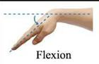

Fig 5-1 Move Forward

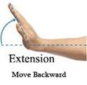

Fig 5-2 Move Backward

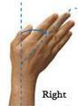

Fig 5-3 Move Right

The robot only moves when the accelerometer is moved in a specific direction. The valid movements are as follows:

|  |  |
| --- | --- |
| **DIRECTION** | **ACCELEROMETER ORIENTATION** |
|  |  |
| Forward | +y |
|  |  |
| Backward | -y |
|  |  |
| Right | +x |
|  |  |
| Left | -x |
|  |  |
| Stop | Rest |
|  |  |

Table 5-1 Accelerometer Orientation

***LIMITATIONS AND FUTURE WORK***

* The on-board batteries occupy a lot of space and are also quite heavy. We can either use some alternate power source for the batteries or replace the current DC Motors with ones which require less power.
* Secondly, as we are using RF for wireless transmission, the range is quite limited; nearly 50-80m. This problem can be solved by utilizing a GSM module for wireless transmission. The GSM infrastructure is installed almost all over the world. GSM will not only provide wireless connectivity but also quite a large range.
* Thirdly, an on-board camera can be installed for monitoring the robot from faraway places. All we need is a wireless camera which will broadcast and a receiver module which will provide live streaming.

**CHAPTER 4**

**System Development**

**4.1 Specifications:**

Input: Real-time serial data from accelerometer

Database : Test data of samples of gestures

Output: Operation or condition according to the matched gesture is performed

**4.2 System Requirements:**

Platform: MATLAB R2010a, MATLAB R2012a

Processor: 2.4 GHz or higher Core 2 Duo, i3, i5 or i7 processor.

RAM: 1 GB or higher.

Operating System: Windows 7, Windows 8 or higher.

**4.3 Hardware Requirements:**

Arduino Uno Board for Development

3-axis Accelerometer

DC Motor as Load

**`**

**4.4 Block Diagram:**

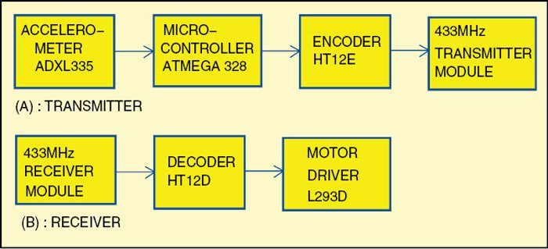

Figure 3: Block Diagram of Gesture Recognition System

Gesture recognition- Acquiring real time serial data from the accelerometer

Processing- Processing or filtering of the serial data.

**4.5 Flow Charts:**

4.4.1 Systematic Flow Chart:

START

Accquire serial data from Accelerometer

Pre-processing

Approach

Output

|  |
| --- |
| **CHAPTER 5**  **Implementation of System** |

This stage of the project basically involves the execution of the before mentioned algorithms viz.

**5.1 Detailed System Algorithm:**

Sample the accelerometer data given from the motion sensor to the Arduino ADC for recorded gestures.

High pass filter the sampled data to remove DC offset (Due to gravity).

Take the testing data for comparison and filter it.

Implement the dynamic time warping algorithm to find the minimum distances between X, Y and Z data arrays for testing data and recorded gestures.

Add the values of the minimum distances for X, Y and Z for each gesture with the sample data.

Find the minimum out of these added values and it will correspond to the recognized gesture.

**CONCLUSION**

We have thus implemented Gesture recognition using a 3 axis accelerometer and a Dynamic Time Warping Algorithm.

We achieved our objective without any hurdles i.e. the control of a robot using gestures. The robot is showing proper responses whenever we move our hand. Different Hand gestures to make the robot move in specific directions are as follow:



 Fig 5-1 Move Forward

Move Backword

CODE:

//gesture.ino

constint ap1 = A0;

constint ap2 = A1;

int sv1 = 0;

int ov1 = 0;

int sv2 = 0;

int ov2= 0;

void setup()

{

// initialize serial communications at 9600 bps:

Serial.begin(9600);

pinMode(13,OUTPUT);

pinMode(12,OUTPUT);

pinMode(11,OUTPUT);

pinMode(10,OUTPUT);

}

void loop()

{

analogReference(EXTERNAL); //connect 3.3v to AREF

// read the analog in value:

sv1 = analogRead(ap1);

ov1 = map(sv1, 0, 1023, 0, 255);

delay(2);

sv2 = analogRead(ap2);

ov2 = map(sv2, 0, 1023, 0, 255);

delay(2);

Serial.print("Xsensor1 = " );

Serial.print(sv1);

Serial.print("\t output1 = ");

Serial.println(ov1);

Serial.print("Ysensor2 = " );

Serial.print(sv2);

Serial.print("\t output2 = ");

Serial.println(ov2);

if(analogRead(ap1)<514 &&analogRead (ap2)<463) // for backward movement

{

digitalWrite(13,HIGH);

digitalWrite(12,LOW);

digitalWrite(11,HIGH);

digitalWrite(10,LOW);

}

else

{

if(analogRead(ap1)<486 &&analogRead (ap2)>508) // for left turn

{

digitalWrite(13,LOW);

digitalWrite(12,HIGH);

digitalWrite(11,HIGH);

digitalWrite(10,LOW);

}

else

{

if(analogRead(ap1)>512 &&analogRead (ap2)>560) // for forward

{

digitalWrite(13,LOW);

digitalWrite(12,HIGH);

digitalWrite(11,LOW);

digitalWrite(10,HIGH);

}

else

{

if(analogRead(ap1)>550 &&analogRead (ap2)>512)//for right turn

{

digitalWrite(13,HIGH);

digitalWrite(12,LOW);

digitalWrite(11,LOW);

digitalWrite(10,HIGH);

}

else

{

digitalWrite(13,HIGH);

digitalWrite(12,HIGH);

digitalWrite(11,HIGH);

digitalWrite(10,HIGH);

}

}

}

}

}

**Simulation:Transmitter**

**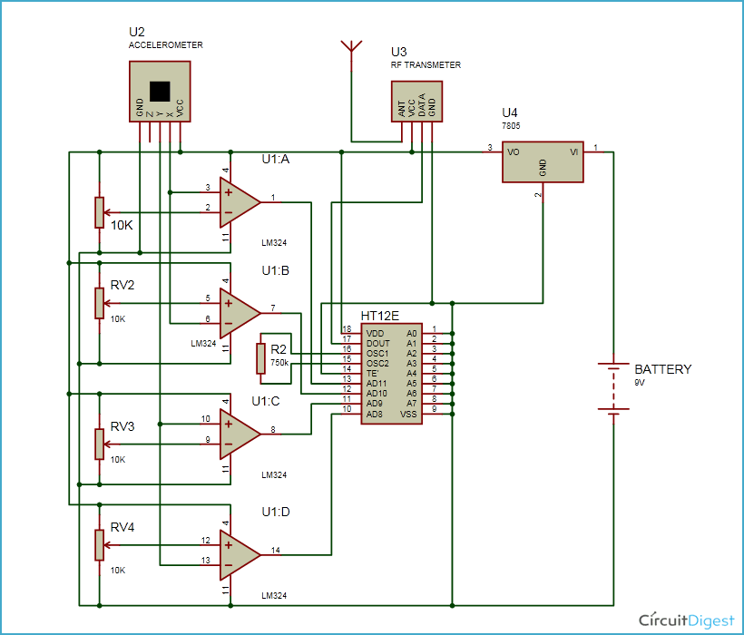  
2)Reciver**

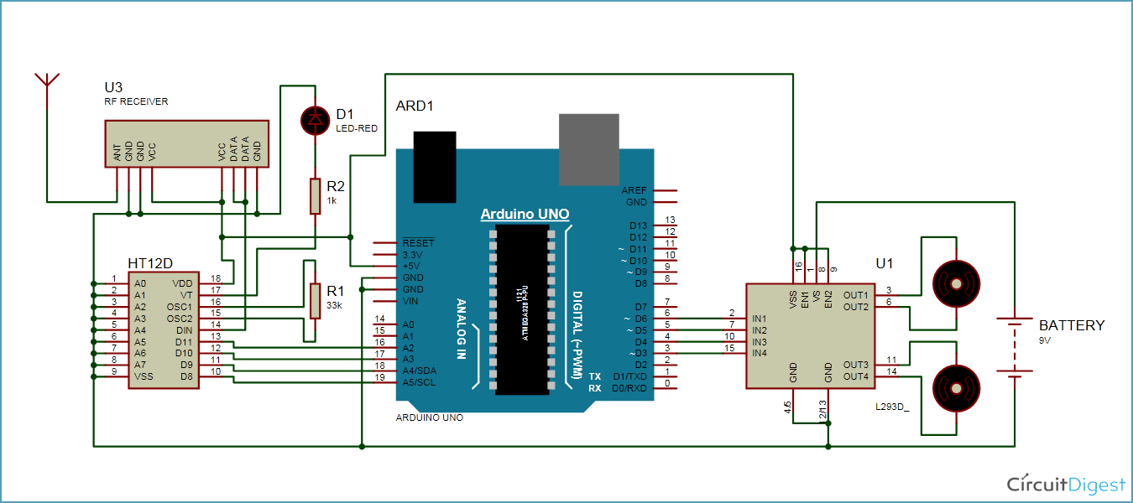

**TRANSMITTER PCB**

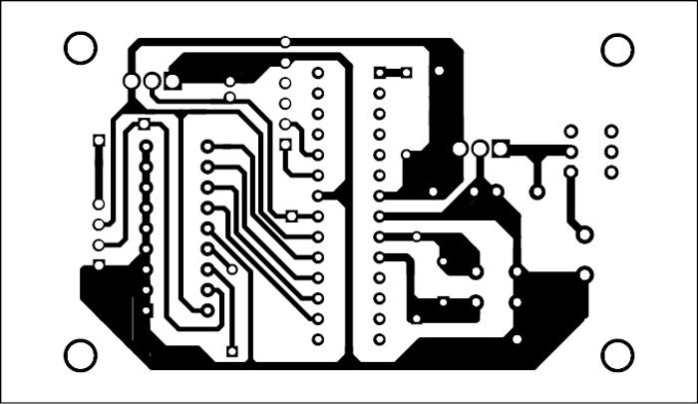

**RECEIVER PCB**

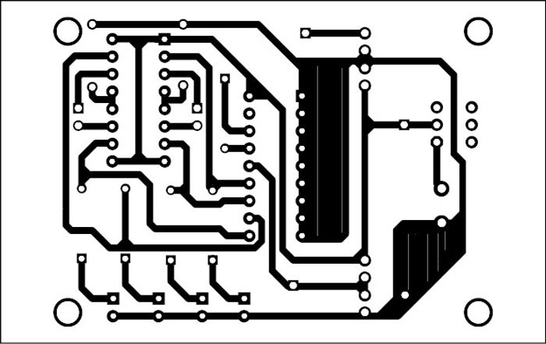

**TRANSMITTER PCB**

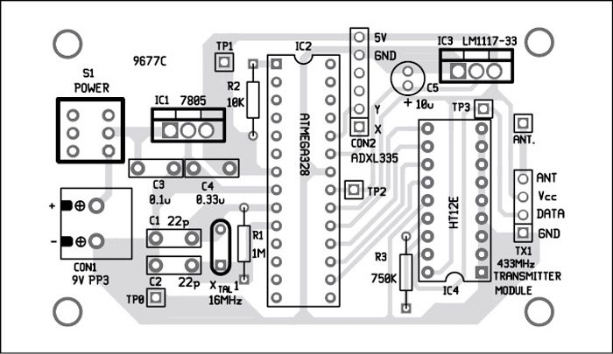

**RECEIVER PCB**

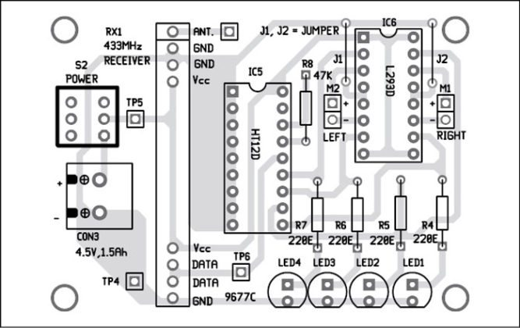

**TRANSMITTER PCB**

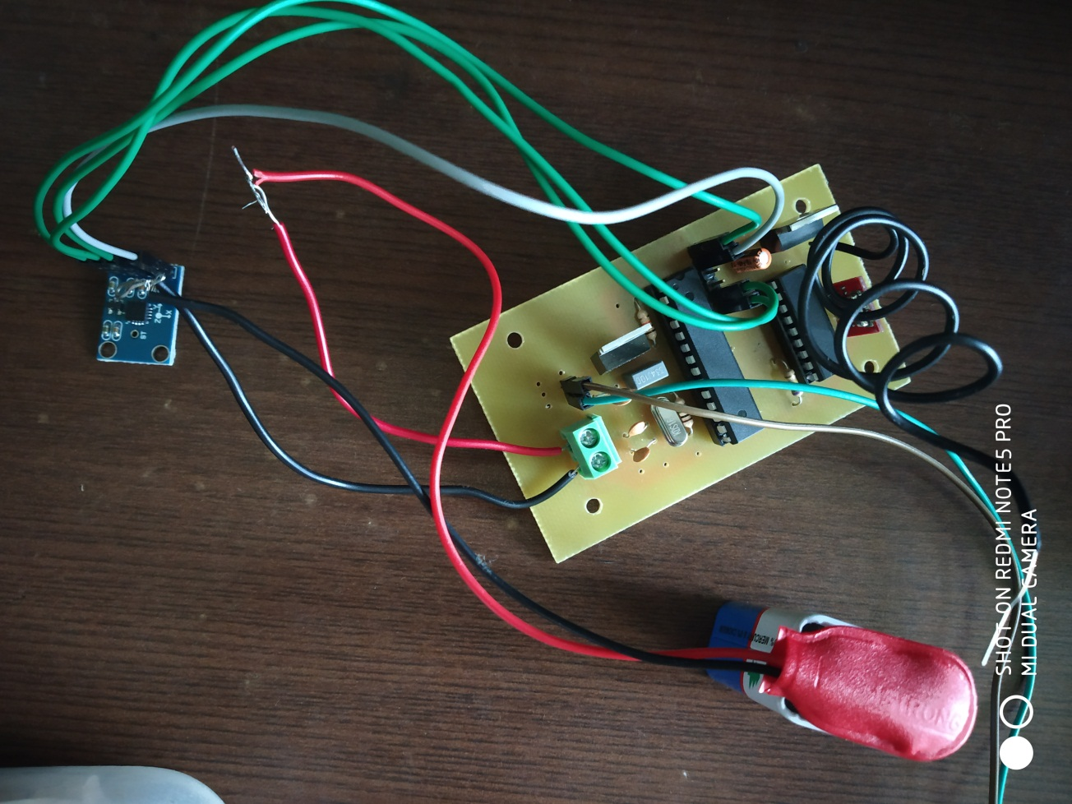

**RECEIVER PCB**

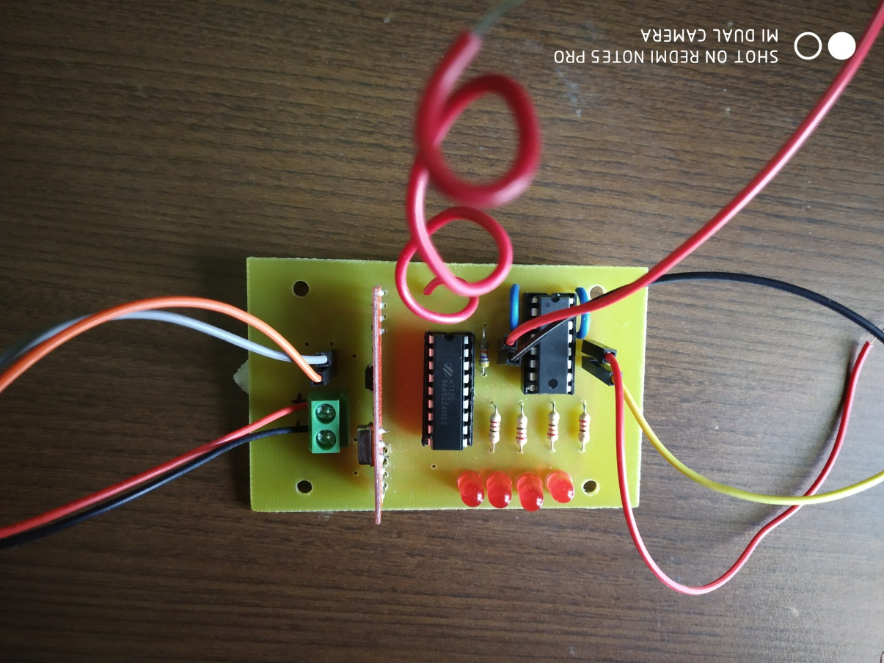

**FINAL PROJECT HARDWARE**

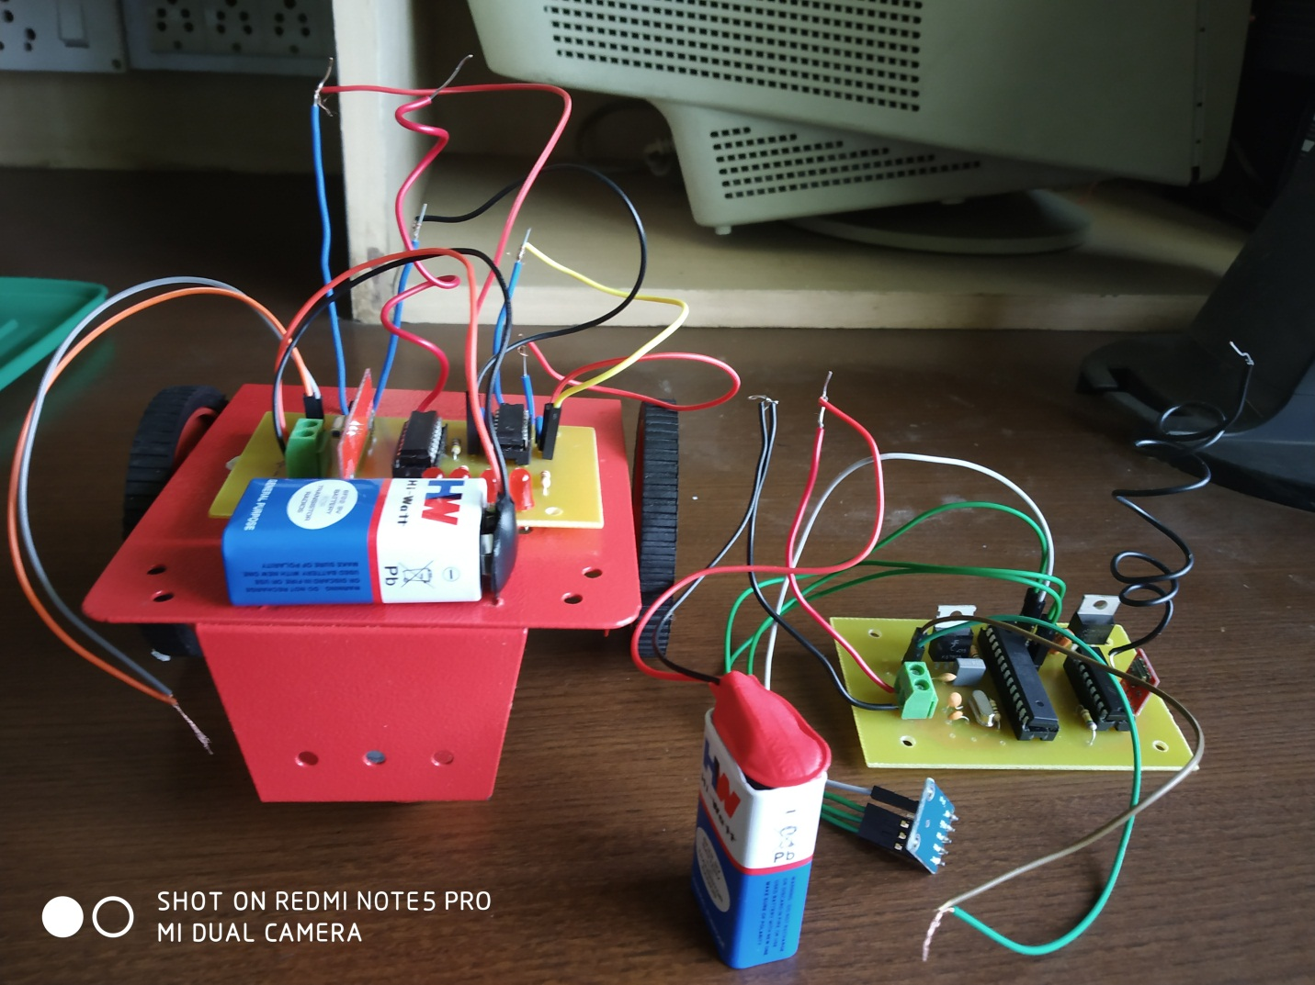

**RESULTS:**

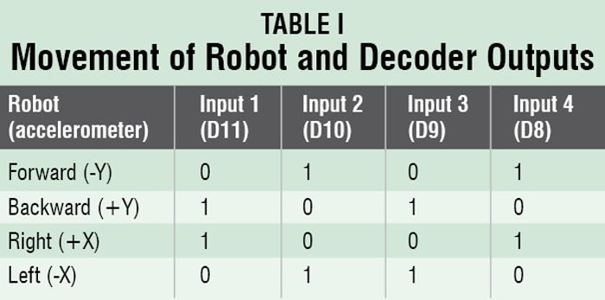

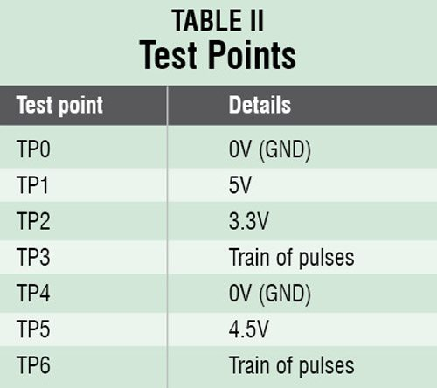

**REFERENCES**

1.E. Keogh, C. A. Ratanamahatana, “Exact Indexing of Dynamic Time Warping”, In Proceedings of International Conference on Very Large Data Bases (VLDB), pp. 406-417, 2002.

2.A. D. Wilson, “Parametric Hidden Markov Models for Gesture Recognition” , IEEE Transactions on Pattern Analysis and Machine Intelligence, vol.21, no.9, pp.884-900, Sep 1999.

3.ZhangYuye& Van Weisheng;"Research of Traffic Signal Light Intelligent Control System Based On Microcontroller", First international Workshop on Education Technology and Computer Science,pp301-303.2009

4.A.K. Bourke , 1. V. O'Brien , G.M. Lyons; " Evaluation of a thresholdbased

tri-axial accelerometer fall detection algorithm"; Gait & Posture 26 ,194-199,2007

5. Matthias Rehm, Nikolaus Bee, Elisabeth André, [Wave Like an Egyptian – Accelerometer Based Gesture Recognition for Culture Specific Interactions](http://mm-werkstatt.informatik.uni-augsburg.de/files/publications/199/wave_like_an_egyptian_final.pdf), British Computer Society, 2007

6.<https://circuitdigest.com/microcontroller-projects/accelerometer-based-hand-gesture-controlled-robot-using-arduino>

7.https://electronicsforu.com/electronics-projects/hardware-diy/wireless-gesture-controlled-robot/2

|  |  |  |  |  |
| --- | --- | --- | --- | --- |
| **S. NO** | **COMPONENT** | **AMOUNT** | **RATE (PKR)** | **COST (PKR)** |
|  |  |  |  |  |
| 1 | AN7805 Voltage regulator | 2 | 12 | 24 |
|  |  |  |  |  |
| 2 | DC Motors | 2 | 80 | 160 |
| 3 | 1uF Capacitor | 2 | 5 | 10 |
|  |  |  |  |  |
| 4 | Accelerometer (ADXL335) | 1 | 236 | 236 |
|  |  |  |  |  |
| 5 | Comparator IC (LM324) | 1 | 15 | 15 |
|  |  |  |  |  |
| 6 | 10K Variable Resistor | 4 | 5 | 20 |
|  |  |  |  |  |
| 7 | Encoder IC | 1 | 200 | 200 |
|  |  |  |  |  |
| 8 | 470K ohm Resistor | 2 | 2 | 4 |
|  |  |  |  |  |
| 9 | RF Module (Rx/Tx) | 1 | 101 | 101 |
|  |  |  |  |  |
| 10 | LED | 1 | 2 | 2 |
|  |  |  |  |  |
| 11 | 330 ohm Resistor | 1 | 2 | 2 |
|  |  |  |  |  |
| 12 | Decoder IC () | 1 | 325 | 325 |
|  |  |  |  |  |
| 13 | Microcontroller (ATMEGA328P) | 1 | 85 | 85 |
|  |  |  |  |  |
| 14 | Crystal Oscillator (11.0592 MHz) | 1 | 10 | 10 |
|  |  |  |  |  |
| 15 | 33pF Capacitor | 2 | 1 | 2 |
|  |  |  |  |  |
| 16 | Motor Driver IC (L293D) | 1 | 110 | 110 |
|  |  |  |  |  |
| 17 | 1N4007 Diode | 8 | 1 | 8 |
|  |  |  |  |  |
| 18 | 9VBattery | 2 | 25 | 50 |
|  |  |  |  |  |
|  | TOTAL |  |  | RS:1364 |